
SWINBURNE VIETNAM
ALLIANCE PROGRAM

CORE PLATFORM FUNCTIONALITIES
by Truong Ngoc Gia Hieu | Pham Nguyen Minh Hoang | Dinh Hoang Phuc

Department: Swinburne University of Technology
Course Name: COS10025 – Technology in an Indigenous Context Project (HCMC)
Instructor Name: Hang Sam Nang
Submission Date:
Word count: 3132 words
Table of Content
Part A
  - Project Overview 3
  - Introduction of the problem 3
Part B
  - Phase 1: Community Consultation, Needs Assessment, and Platform Strategy 3
Description 3
Research and Analyze 4
Decision 4
  - Phase 2: Platform Design and Development 4
Description 4
Digital Literacy Level 5
Design Thinking Application 5
Technical Implementation 6
User/Customer interface 7
Artisan Community Interface 8
Administrative Interface 9
Beneficial 10
Conclusion 11
Part C
References 12

Part A
  - Project Overview
The Request for Proposal (RFP) Organization launches the project named 'E-Commerce Platforms for Traditional Handicrafts from Southern Vietnam' in the course 'Technology in an Indigenous Context – COS10025,' allowing students to immerse themselves into a fascinating project that applies cutting-edge technologies to improve the economic empowerment and cultural preservation of diverse artisan communities across Southern Vietnam, particularly those of Indigenous and ethnic minority groups.
Additionally, the project aims to establish sustainable and user-friendly interfaces with various categories and functions for both the artisan community and the customer, offering unique experiences and great interactions. Moreover, according to the detailed document, the customer platform must have secure payment and logistics integration, as well as features for product listing, order management, Browse, and purchasing. Furthermore, the project not only directly benefits artisan communities and preserves cultural heritage but also champions fair trade practices. In addition, the project seeks to preserve cultural heritage by increasing awareness and appreciation of traditional crafts and their cultural significance. Due to these reasons, the RFP decided to implement this exciting project into the course, offering significant opportunities for students to research, analyze, and discover different customs and practices while utilizing the latest innovations to solve complex problems for indigenous people and minority groups.
  - Introduction to Problems
First and foremost, traditional handicraft artisan communities in Southern Vietnam, particularly Indigenous and ethnic minority groups, face significant challenges in accessing broader markets and sustaining their livelihoods. These difficulties often stem from limited digital literacy, lack of access to effective online sales channels, and difficulties in managing logistics and secure payments for their unique products. There is a constant need to ensure their cultural authenticity and stories are accurately and respectfully represented online, alongside efforts to combat issues like unfair pricing and a lack of direct benefits from sales. Without sustainable and community-owned e-commerce solutions, these communities risk losing economic opportunities and the ability to preserve their valuable cultural heritage and traditional skills for future generations. Consequently, developing sustainable, culturally appropriate, and community-managed e-commerce platforms is crucial to overcoming these challenges, empowering Southern Vietnam's artisan communities, and ensuring the long-term preservation of their cultural heritage and economic viability through fair trade practices.
Part B
2.1 Phase 1: Community Consultation, Needs Assessment, and Platform Strategy
2.1.1 Description
According to the detailed requirements, Phase 1 involves a comprehensive and culturally sensitive approach to understanding the needs of traditional artisan communities in Southern Vietnam. The project requires comprehensive consultations to identify market access challenges, digital literacy levels, and specific e-commerce platform preferences, alongside an assessment of existing organizational structures and concerns related to online sales. Before developing complex platforms, team members will research, analyze, and gather crucial information about various provinces across Southern Vietnam, serving as the foundation for the final decision. During the information collection phase, the team will carry out a detailed needs assessment, based on community consultations, to identify the specific functionalities, features, and support mechanisms required for effective e-commerce platforms. Ultimately, implementing effective e-commerce platforms is essential for addressing the identified challenges, ensuring cultural relevance, and maximizing the positive impact on the artisan communities of Southern Vietnam.
2.1.2 Research, Analyze, and Gather Information
Based on the Phase 1 requirements, team members leverage powerful applications and sophisticated methodologies including Google Docs and Google Scholar to compile relevant information that will critically inform the selection of the most suitable province for subsequent project phases. During the process, the team discovered several provinces, each with its own unique handicrafts. For example, An Giang province is recognized for Khmer brocade and palm sugar, while Ben Tre province is known for a variety of coconut-based goods. Secondly, Đồng Tháp Province excels in traditional mat weaving and distinctive Lai Vung products. Thirdly, Kiên Giang Province offers traditional rice paper and water hyacinth handicrafts, showcasing the cultural diversity and regional identity. Lastly, Vĩnh Long Province stands out for its unique red pottery. After finishing this comprehensive information gathering and analysis, the team will be able to strategically select the most suitable province to move forward to the next phases.
2.1.3 Decision
First and foremost, the team identified two provinces as particularly outstanding among others across Southern Vietnam, namely Kiên Giang and Đồng Tháp Provinces. This distinction was based on their exceptional cultural heritage, the rich diversity and uniqueness of their traditional handicrafts, and their significant potential for sustainable economic empowerment through e-commerce, which aligns strongly with the project's core objectives. Therefore, considering various external and internal factors, the team decided to select Kiên Giang Province, as it offers substantial opportunities to enhance the provincial economy, improve digital literacy, boost tourist attractions, and elevate the quality of life for local people in general, especially for traditional villages.
2.2 Phase 2: Platform Design and Development
2.2.1 Description
The requirements of Phase 2 in the detailed document focus on the technical creation of the e-commerce platforms. Moreover, the phase involves designing intuitive, user-friendly interfaces for both artisans and customers, keeping in mind varying levels of digital literacy, providing distinctive engagement and enriched user journeys. Therefore, core activities include developing robust and secure e-commerce platforms based on defined technical requirements, integrating secure payment gateways, and establishing logistics and shipping solutions. Notably, the platform must feature multi-language integration, with a primary focus on Vietnamese and English, and comprehensive mobile optimization. In summary, the specifications of this phase not only mandate the implementation of sustainable and user-friendly interfaces with multiple functions and categories, but also aim to showcase the unique traditional artifacts, products, their profound historical significance, and facilitate cultural preservation.
2.2.2 Digital Literacy Level
Based on the research and analysis phase, the results show that the digital literacy landscape, much like other provinces across Southern Vietnam, presents a mixed picture. While urban areas and younger generations swiftly adopt remarkable and cutting-edge technologies, rural areas and older demographics often face challenges. These significant challenges limit people's access to high-speed internet, a lack of affordable devices, and, crucially, a varying degree of foundational digital skills. Subsequently, dramatic efforts are being launched to improve digital literacy across the province through government initiatives, community programs and workshops, and educational outreach, aiming to empower all residents to participate fully in the digital economy and societal transformation.
For example, in Kien Giang Province, the digital transformation of education is notably progressing through the implementation of the KAV Open School model. This initiative, spearheaded by the Department of Education and Training, offers a fundamental change to traditional learning methods by leveraging information technologies. Despite a wide range of challenges in deploying IT infrastructure to remote island schools, significant government commitment has ensured internet access and ongoing facility investments. Currently, the KAV Open School enables flexible online study for students and efficient assignment/evaluation for teachers, ultimately striving to improve overall learning quality across the province.
Additionally, Kien Giang province in Vietnam is actively undergoing digital transformation as part of Project 06, demonstrating significant progress in various sectors. As of September 9, 2024, the province has observed an increase in six out of thirteen digital transformation indicators. Key achievements include a 64.2% rate of online administrative records, with 72.77% of administrative procedure records and results digitized, and a 99% synchronization rate of records on the National Public Service Portal. Additionally, healthcare facilities are integrating data for certificates and notices with the Health Insurance Appraisal Information System, and 97.4% of fishing vessels have updated their information on the national fisheries database 6 (VNFishbase). Furthermore, Kien Giang province is actively boosting digital literacy, seen in the high rates of online administrative procedures and data synchronization on national platforms. Beyond just skills, the launch of a dedicated Cybersecurity and Information Operation Centre plays a vital role in creating a secure digital environment. This foundation of safety and trust is essential for encouraging wider public engagement and ultimately advancing the province's overall digital literacy levels.
2.2.3 Design Thinking Application
The team leader utilizes a design thinking technique during Phase 2, particularly within the community consultation and needs assessment stages, to understand the difficulties faced by local people in general, as well as those encountered by handicraft villages and groups, in a comprehensive and insightful manner. After gathering useful information and engaging in discussions with team members, the team opts to implement three platforms: User/Customer, Artisan Communities, and Administrative platforms, respectively. Moreover, each platform is designed to incorporate unique operational features tailored specifically to address the distinct needs and challenges identified for each stakeholder group, thereby ensuring an optimized, relevant, and effective digital experience for all participants. Notably, the craftsperson's digital portal facilitates the seamless showcasing and trading of their unique, culturally authentic handicraft products directly to a broader audience. As a result, after employing a design thinking approach to comprehensively understand the challenges faced by local people and artisan groups, the team decides to launch three different types of platforms strategically tailored to empower each stakeholder group and foster a sustainable digital marketplace for traditional handicrafts.
2.2.4 Technical Implementation
Based on the project requirements, the entire e-commerce platforms ecosystem will be built on a robust and scalable architecture, utilizing modern technologies to ensure reliability, security, and performance. Therefore, my team implements both web and mobile applications to ensure broad accessibility and an optimized experience across various devices for all user groups.
In addition, the Data Flow Diagram (DFD) technique is employed during the design phase to facilitate a comprehensive understanding of the system's underlying processes. For the development of the frontend, team members choose popular programming languages including HTML, CSS, and Javascript, offering a highly interactive, visually appealing, and responsive user interface across all devices and screen sizes. In contrast, for backend implementation which includes server-side processing, API interactions, and business rule implementation, will be powered by PHP. Moreover, for robust data persistence across the entire ecosystem, the team will strategically implement MySQL, ensuring all critical information, encompassing product catalogs, user details, order records, and financial transactions, will be securely and efficiently stored and managed within a highly reliable relational database environment.
2.2.5 Customer/User Interface
The User/Customer platform functions as an intuitive and aesthetically pleasing e-commerce website and mobile application designed to showcase and sell traditional Vietnamese handicrafts. Therefore, the primary goal of the consumer platform is to offer a seamless and secure shopping experience for customers while ethically representing the artisans and their cultural heritage. Additionally, the interface will feature a clean, user-friendly, minimalist design with a focus on high-quality imagery and video showcasing the handicrafts. Specifically, the consumer interface allows users to sort and filter products based on various criteria, including comments, star ratings, brands, materials, and more. Moreover, secure payment gateways will be integrated, supporting both common local and international payment methods. Furthermore, the platform will include multi-language support (Vietnamese and English initially) to cater to both domestic and international audiences. It will also feature a dedicated customer support section with FAQs, contact forms, and order tracking to enhance the user experience.
The platform design centers on a visually engaging and easily navigable experience, beginning with a responsive homepage. This homepage features prominent sections such as introduction videos, a search bar, curated product categories, and dedicated artisan spotlights to foster cultural connections. Additionally, product detail pages will showcase high-resolution imagery and artisan bios, supported by a secure, multi-step checkout process. Importantly, the entire design is fully responsive, adapting seamlessly across all devices.
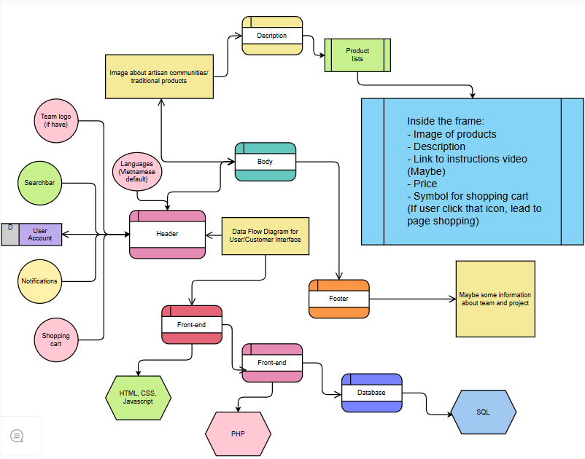
Figure 1: Components of User/Customer interface
The diagram above outlines a high-level conceptual model of a User/Customer platform, representing fundamental functional components and their logical dependencies. Therefore, the interface is composed of three primary sections including Header, Body, and Footer. Additionally, categories including Notifications, Shopping Cart, Searchbar, and Team Logo will be composed in the header part. Specifically, the interface integrates language setting, allowing both local and foreigners to select their preferred language for a more personalized and accessible user experience. Next, the body section features a prominent image of artisan communities or unique traditional products, followed by a descriptive text. Below this, products are displayed in a grid of portrait rectangles, three per line. Then, each border- rectangle contains a product image, description, price, and a shopping cart symbol. Clicking the cart directs users to the "Shopping page". Finally, the footer of the User/Customer platform contains general information about the general project information, providing users with insights into the team and the overall project goals, fostering transparency and trust.
2.2.6 Artisan Community Interface
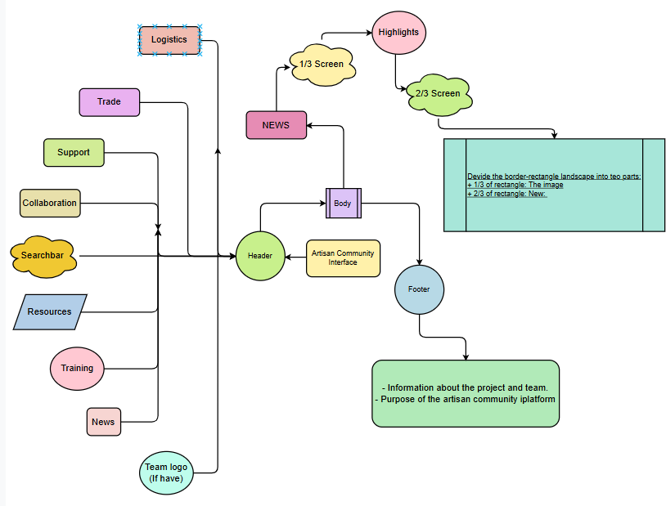
The Artisan Community Platform is a dedicated web and mobile interface designed specifically to empower artisans to manage their online presence, list and trade unique products between villages and communities, process orders, and access training resources. It serves as the artisan's personal online store management system, featuring a user-friendly product listing interface with guidance on photography and description writing, inventory management tools, and an order dashboard to track sales, fulfill orders, and manage shipping. Moreover, the platform aims to be simple, intuitive, and highly functional, enabling artisans with varying levels of digital literacy to effectively participate in the e-commerce ecosystem. A comprehensive resources library provides training materials on product photography, digital marketing basics, quality control, and packaging standards, all in local languages. Notably, a dedicated "News & Updates" module will enable artisan communities to publish and share the latest news and developments related to traditional crafts, both from a national and international perspective, fostering a broader understanding and appreciation of their heritage.
Figure 2: Components of Artisan Community interface
Figure 2 illustrates the complex architecture of the "Artisan Community" platform, allowing skillful workers to connect with clients, showcase their work, collaborate on projects, and find opportunities within a dedicated marketplace. Firstly, the "Header" serves as a central gateway, aggregating various key functionalities such as Logistics, Trade, , Support, Collaboration, a Searchbar, Resources, Training, and News, along with a potential Team Logo. Then, the "Body" of the "Artisan Community Interface" is designed to be divided into two main parts. Additionally, the 1/3 portion will prominently feature Highlight news, offering users a quick glance at the most important updates while the 2/3 portion is conceptualized as a border-rectangle landscape extending from top to bottom. While within the larger section, an image will be strategically placed on the left side to visually showcase the news and the description detailing the news will be presented immediately next to it, providing comprehensive context. As a result, the friendly-user interface aims to offer a visually appealing and informative presentation of news content within the platform. Finally, the "Footer" is designated for essential project information, including details about the team and the overarching purpose of the artisan community platform.
2.2.7 Administrative Interface
The Administrative Platform performs as a secure and comprehensive backend system designed for the issuing organization and authorized personnel to manage the entire e-commerce ecosystem. Additionally, the main purpose of the interface is to oversee platform operations, manage users (customers and artisans), moderate content, analyze performance data, and ensure adherence to fair trade principles and project objectives.
Furthermore, the administrative platform is equipped with a centralized dashboard that facilitates comprehensive management of all platform functionalities. Key features encompass user management, including the approval of artisan accounts and the administration of customer profiles; product moderation, involving the review of new listings to ensure quality standards and cultural appropriateness; order oversight; and dispute resolution mechanisms. Consequently, the restricted interface is endowed with advanced analytics and reporting tools designed to monitor sales performance, user traffic, artisan activity, and overall community engagement. Content management capabilities enable the systematic updating of homepage banners, promotional campaigns, and blog posts. Additionally, robust security measures—such as role-based access control and detailed audit logs—are implemented to guarantee data integrity, enhance security, and ensure regulatory compliance.
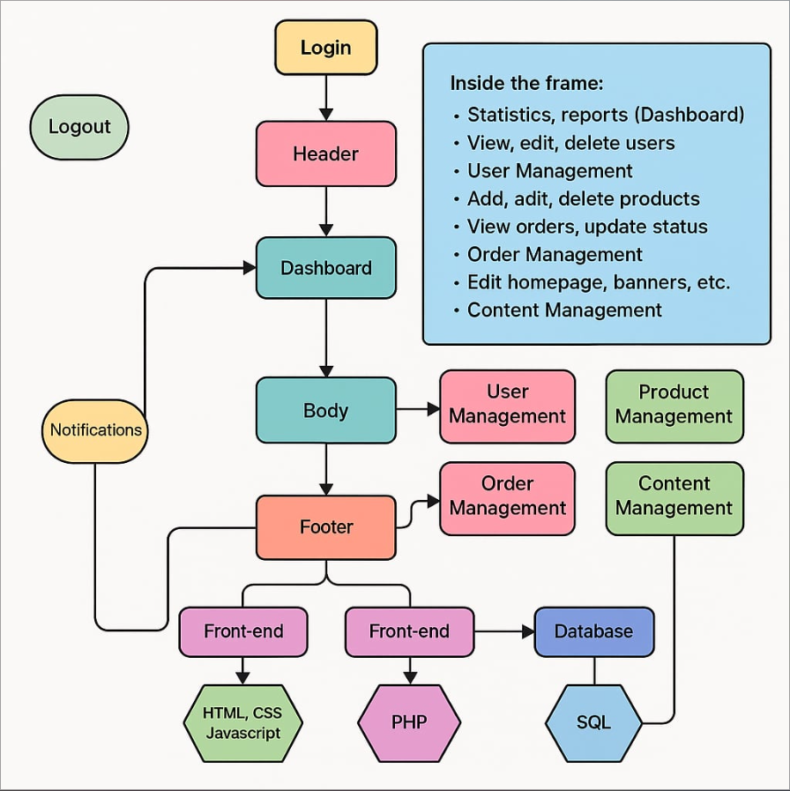
Figure 3: Components of Administrative platform
The Figure 3 illustrates the architectural flow of an administrative backend system, beginning with user login and logout. After successful authentication, the user accesses a "Header" leading to the "Dashboard," a central control panel for managing statistics, reports, users, products, orders, and general website content. From the Dashboard, the system flows into the main "Body," which branches out to dedicated modules for "User Management," "Product Management," "Order Management," and "Content Management." A "Footer" is present at the bottom, and "Notifications" are a side element connected to the Dashboard. The entire system's functionality is supported by a "Front-end" using HTML, CSS, and Javascript, another "Front-end" element powered by PHP, both interacting with an SQL "Database."
2.2.8 Beneficial
For adapting the project, implement multiple e-commerce platforms including User/Customer, Artisan Community, and Administrative interfaces, is crucial for the project's success. Furthermore, the Consumer Interface provides intuitive Browse and purchasing experiences, significantly expanding market access for traditional handicrafts and increasing their appreciation. Next, the Artisan Community platform empowers artisans with essential tools for product listing, inventory, and order management, thereby enhancing their digital literacy and business skills, and directly improving their income. Finally, the Administrative Platform is vital for enabling community ownership and effective management of the e-commerce ecosystem, ensuring adherence to fair trade principles, ethical representation, and the long-term sustainability of the entire initiative.
2.2.9 Conclusion
In conclusion, engaging in the project 'E-Commerce Platforms for Traditional Handicrafts from Southern Vietnam' within the course 'Technology in an Indigenous Context - COS10025' enables team members to gain a deep understanding about the importance of cultural preservation. In addition, utilizing powerful techniques, including Design Thinking and Data Flow Diagram (DFD), assists the team in discussing, researching, and analyzing the challenges of artisan communities and villages across Southern Vietnam in general, and Kien Giang province in particular, more easily and productively. Finally, this comprehensive approach culminates in the development of robust and culturally sensitive e-commerce platforms poised to empower artisan communities, expand market access for traditional handicrafts, and contribute significantly to their sustainable economic and cultural preservation.

Part C
References
- Baoquocte. (n.d.). Kien Giang: To transform education digitally through KAV Open School in the era of advancement.
https://en.baoquocte.vn/kien-giang-to-transform-education-digitally-through-kav-open-school-in-the-era-of advancement-291961.html
- Kien Giang Province. (n.d.). Kien Giang is 1 of 7 key provinces nationwide implementing Project 06.
https://www.baokiengiang.vn/trong-tinh/kien-giang-la-1-trong-7-tinh-trong-diem-trong-ca-nuoc-trien-khai thuc-hien-cac-nhiem-vu-de-an-06-22155.html
- Kien Giang Province. (n.d.). Kien Giang is 1 of 7 key provinces nationwide implementing Project 06.
https://vietnamnews.vn/society/793304/kien-giang-province-launches-cybersecurity-and-information operation-centre.htm

